PRESS RELEASE
October 6th, 2017

The evaluation procedure of the research works candidates at the OENOPPIA SIVE AWARD 2017 was completed, and identified the winner in doctor Ricardo Chagas, by Laqv Requimte (Universidade Nova de Lisboa).

The competition is promoted by SIVE (Società Italiana di Viticoltura ed Enologia, Italian Society of Viticulture and Enology) to foster dialogue between research and production in the wine sector.
Distinctive character of the SIVE Award is the primary role played by wine industry stakeholders, agronomists and winemakers, who decide the winner on basis of the usefulness of the results for the development of the sector. The research works were presented to a large audience of stakeholders at Enoforum 2017, the last edition of the event hold every two years in Italy that became a unique international opportunity of meeting and dialogue between professionals of wine and grape production, researchers and suppliers. The candidate researchers were previously screened by a Scientific Committee composed in 2017 by 49 scientists (23 Italians, 16 Europeans and 10 from extra-EU wine countries).

The SIVE OENOPPIA AWARD 2017 is sponsored by the association Oenoppia, gathering the main world actors in production and development of oenological products, on line with its policy of active contribution to the progress of scientific knowledge in favor of the wine industry.
Thirty-six research works from 26 research groups of different countries candidates to the 2017 award. The Scientific Committee selected among them the 12 concerning the most innovative topics, that became part of the Enoforum congress program.
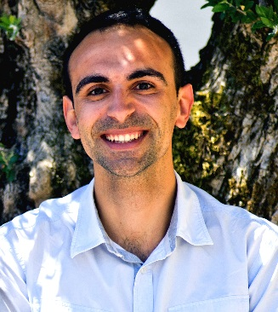
The research best evaluated by industry stakeholders was the Chagas work titled “Protein haze formation in white wine - The critical involvement of sulfur dioxide in protein aggregation mechanism”, about the role, unknown to the most, that sulfur dioxide has in creating di-sulphite bonds between instable proteins and causing their precipitation. The 7.500 € price, devolved to LAQV REQUIMTE research found, was founded by Oenoppia.

Other research works ranked after the winner, but obtained very high evaluation scores and deserve to be mentioned:

- Wine-Oxygen-Antioxidants: How to address more effectively the winemaker choices, Panagiotis Arapitsas, Fulvio Mattivi, Fondazione Edmund Mach San Michele all’Adige; Maurizio Ugliano, Università di Verona
- Immobilization of yeasts in oak chips and cellulose powder for use in bottle-fermented sparkling wine, Carmen Berbegal, Lucía Polo, Isabel Pardo, Sergi Ferrer, ENOLAB, ERI BioTecMed, Universitat de Valencia, M.José Garcia Esparza, Tecnología de Alimentos, Univesitat Politecnica de Valencia
- Evolutionary strategies to develop high-Glutathione yeast strains for winemaking, Tommaso Bonciani, Luciana De Vero, Paolo Giudici, Dipartimento di Scienze della Vita, Università di Modena e Reggio Emilia
- Deciphering the wine ageing bouquet: sensory and molecular study of a complex olfactory concept, Magali Picard, Gilles de Revel, Stéphanie Marchand, ISVV, Université de Bordeaux

The awards ceremony will take place on January 2018, during a dedicated full day SIVE technical meeting.

The SIVE AWARDS “research for development” are granted on the basis of the judgment expressed by wine industry stakeholders.
The selection procedure foresees three phases:
- The abstracts of the submitted researches will be anonymously evaluated by the SIVE Scientific Committee for the criterion "degree of innovation and interest on the topic".
- The works that receive the highest scores will be orally presentation at the next Enoforum; participants attending Enoforum and the SIVE associated judge them on the basis of the criterion "benefit of research for the development of the wine industry”.
- SIVE Scientific Committee further judges the researches with respect to the criterion "scientific value", based not only on the summary, but on the full presentations

Two SIVE Award has been established, each with a grant of € 7.500:
- VERSINI Award since 2007 (called VERSINI ASSOENOLOGI starting from 2017), reserved to Italian researchers
- OENOPPIA Award, established in 2013 and open to scientists of any country

The winners of the past editions were:
- VERSINI Award 2007: Emilio CELOTTI, Giuseppe CARCERERI de Prati and Paolo FIORINI - “Moderno approccio alla gestione della qualità delle uve rosse”
- VERSINI Award 2009: Raffaele GUZZON, Agostino CAVAZZA and Giovanni CARTURAN -“Immobilizzazione di starter malo lattici. Tecnologia, effetti biologici e fermentazioni sperimentali con ceppo di O. oeni immobilizzati in matrici ibride silice/alginato”
- VERSINI Award 2011: Matteo GATTI, S. CIVARDI, F. BERNIZZONI, S. PONI - “Effetti differenziali del diradamento dei grappoli e della defogliazione precoce su resa, composizione delle uve e qualità dei vini in Sangiovese”
- VERSINI Award 2013: Diana GAZZOLA, S. VINCENZI, A. CURIONI - “Valutazione delle capacità chiarificanti di un nuovo coadiuvante proteico estratto da vinaccioli”
- OENOPPIA Award 2013: Ramon MIRA DE ORDUÑA - “Full automation and control of vinifications by FT-NIR spectroscopy: An innovation presenting ground-breaking opportunities”
- VERSINI Award 2015: Fabio CHINNICI and Claudio Riponi, “Controllo dell’ossidazione di (+)-catechina mediante chitosano: ipotesi di utilizzo in vinificazioni a ridotto contenuto in solfiti”
- OENOPPIA Award 2015: Vicente FERREIRA “Understanding and managing reduction problems”
- VERSINI ASSOENOLOGI Award 2017: Daniela FRACASSETTI, Sara Limbo, Antonio Tirelli, “Il gusto di luce nel vino bianco: meccanismi di formazione e prevenzione”

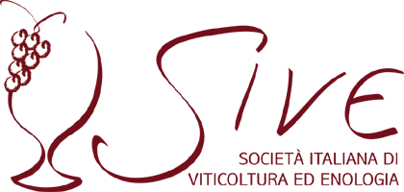
SIVE (Società Italiana di Viticoltura ed Enologia) is a non-profit association of wine professionals operating in all Italian regions and of companies active in the wine industry. Since 1996 promote education and professional training on wine; through its Secretariat VINIDEA, has organized more than hundred between congresses, seminars, workshops and educational tours in Italy and several other wine countries. Every two years SIVE and VINIDEA organize the event Enoforum.
Since 2005, SIVE policy is to promote a better cooperation between wine producers and scientists, helping the production people to better identify their need and to formulate clear and suitable queries to researchers, and these last to prioritize their work on the topics of most usefulness for wine production.
SIVE awards were established to contribute in reaching this goal and – since 2007 to now – 293 researches participate the competition that, therefore, represents a very wide view of scientific production in the last decade, brought to the knowledge of thousands of stakeholders.

Sive awards “research for development” are funded by Oenoppia, Assoenologi and Fondazione Edmund Mach.

OENOPPIA is a non-profit association created in 2009 and grouping together the principal parties involved in the production and development of oenological products. The 18 members of Œnoppia represent approximately 85% of oenological products used by wine makers throughout the world. They have a strong wine culture and an international approach to the vitivinicultural world, which is expressed via the creation of this association. The groups comprising Œnoppia have for decades founded their development on research and innovation, and for the oldest, for over a hundred years. Their expertise in oenological applications is the result of internal development or long-term partnerships with major universities and institutes throughout the world. They have initiated a large number of publications and patents guided by the research of the best possible expression of the potential quality of the grapes.
The International SIVE Award “Oenoppia” is the further concrete expression of oenological profession involvement to support general knowledge about phenomena at play in the transformation of grapes into wine.
The members of Oenoppia are: AB Group, Agrovin, AEB, Eaton, Bioseutica, Dal Cin, Enologica Vason, Chr. Hansen, DSM-Oenobrands, Erbslöh - La Littorale, Esseco-Sofralab, Fermentis, Laffort, Lallemand, Lyven, Novozymes, Silvateam, Cofalec.

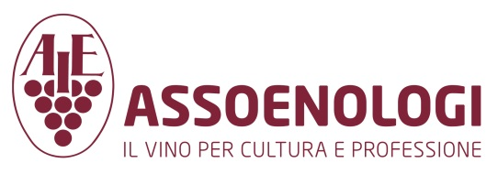
ASSOENOLOGI, “Associazione enologi enotecnici italiani”
It proposes the protection of the winemakers, oenologists and the technicians in the wine sector in general, under the ethical, juridical, economical point of view and represents the category at all levels.
Assoenologi supports viticultural and oenological research, promotes experimentation and technical update of its associated.

Fondazione Edmund Mach is an institute that does scientific research, experimentation, education and training, consultancy and services to the agricultural, environmental and food industry field.
The foundation continues the activity of the Agricultural Institute of San Michele all’Adige, and is structured in three different poles: the Education and Training Center, the Research and Development Center and the Technological Transfer Center.

Pictures in high resolution version are available on request to a sive@vinidea.it

